First year Enginerring

WORKSHOP MINI PROJECT

**on**

**SMART DUSTBIN**

(USING ARDUINO UNO AND SERV0)

**SUBMITTED BY**

**RIMJHIM KAMBLE : 19101A0059**

**UNNATI GOHIL : 19101A0069**

**SHALAKA SONAWANE : 19101A0062**

**RIDDHI WARALE : 19101A0057**

**Guided By**

**Vidya Chitre**

**Vidyalankar**

**Depart**

2019-2020

**INDEX**

**INDEX**

1. **ABSTRACT**
2. **WHAT IS A SMART DUSTBIN**
3. **LIST OF COMPONENTS USED**
4. **CIRCUIT DIAGRAM**
5. **EXPLANATION OF COMPONENTS**
6. **WORKINF OF SMART DUSTBIN**
7. **LIMITATIONS**
8. **CONCLUSIONS**
9. **REFERENCES**

**ADVANCED**

**DUSTBIN**



**CERTIFICATE**

This is to certify that report entitled  **“smart dustbin”** ,has been partially submitted for First Year , **Semester -I of Bachelor of Information Technology** during academic year 2019-2020.

by

**Miss Rimjhim Kamble,**

**Miss Unnati Gohil,**

**Miss Riddhi Warale**

**Miss Shalaka Sonawane**

under my guidance and supervision

Name Roll No Signature

**RIMJHIM KAMBLE : 19101A0059**

**UNNATI GOHIL : 19101A0069**

**SHALAKA SONAWANE : 19101A0062**

**RIDDHI WARALE : 19101A0057**

**Name and Signature of Subject teacher :**

DATE :

PLACE: MUMBAI

**ACKNOWLEDGEMENT**

**I Express my sincere respect and gratitude to my subject teacher who has given her valuable support cooperation and suggestions from time to time in successfully completing this**

**Project.**

**ABSTRACT**

**The issue of getting hands on the dirty dustbin has now been easily solved using this smart dustbin and we don’t have to waste our energy in opening the bin which may be already be touched with dirty hands or other dirty materials.**

**WHAT IS A SMART DUSTBIN?**

**It’s a very smart and convenient way to get our garbage its actual place without touching the dustbin ,that is now the dustbin being smart will sense you and open automatically and you can throw the garbage without you having to touch the dustbin since the cover of the dustbin will automatically open using the Arduino.**

**List of components**

**1.Dustbin**

**2.Arduino Uno**

**3.Servo 96**

**4.Ultrasonic sensor**

**5. 9v battery**

**Circuit diagram:**

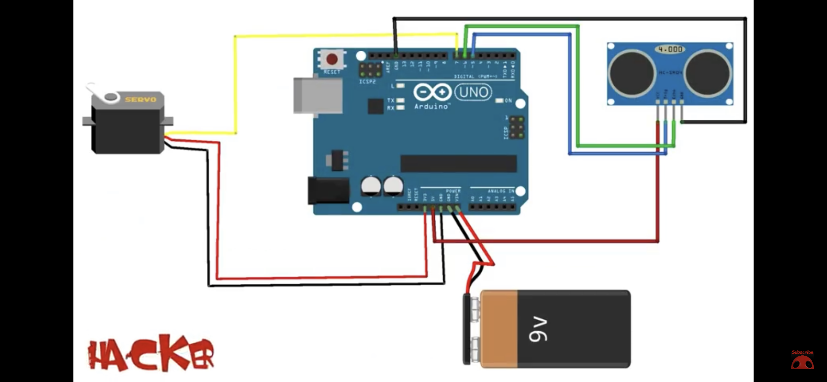

**Explanation of components:**

**Arduino Uno:**

**The Arduino Uno R3 Compatible Board is a microcontroller board which is based on the ATmega328. Arduino Uno has 14 digital input or output pins(where 6 can be used as PWM outputs), 6 analogue inputs, a 16 MHz ceramic resonator, a USB connection, a power jack, an ICSP header, and a reset button. It has everything needed to support the microcontroller, you need to simply connect it to a computer with a USB cable or power it with an AC-to-DC adapter or battery to get started.**

**Features:**

* **Easy application programming using open source IDE**
* **Easy to learn Microcontroller using Arduino boards.**
* **256k Flash**
* **Easy application programming using open source IDE**
* **Ready Library for most of sensors and applications module.**

**Specification:**

**ATmega328 Controller**

**Digital IO 13**

**PWM Channel 6**

**Working Freq. 16MHz**

**DC current / IO 40mA**

**DC current / IO 50mA (3.3V)**

**Input Voltage 6V to 20V DC**

**Flash 32Kb**

**SRAM 2Kb**

**EEPROM 1K**

**Ultrasonic sensor:**

**Working Voltage : 5V(DC)  
Static Current: Less than 2mA.  
Output Signal: Electric frequency signal, high level 5V, low level 0V.  
Sensor Angle: Not more than 15 degrees.  
Detection Distance: 2cm-450cm.  
High Precision: Up to 0.3cm  
Input Trigger Signal: 10us TTL impulse  
Echo Signal : output TTL PWL signal  
Mode of connection:  
VCC  
trig(T)  
echo(R)  
GND**

**9G micro servo motor:**

**The Micro Servo 9G is lightweight, high-quality and lightning-fast. The servo is designed to work with almost all the radio control systems. It is with excellent performance brings you to another horizon of flight. The SG90 mini servo with accessories is perfect for R/C helicopter, plane, car, boat and truck use.**

Features:

**Required Pulse: 3-5 Volt Peak to Peak Square Wave  
Operating Voltage: 4.8-6.0 Volts  
Operating Temperature Range: -10 to +60 Degree C  
Operating Speed (4.8V): 0.12sec/60 degrees at no load  
Operating Speed (6.0V): 0.10sec/60 degrees at no load**

**Stall Torque (4.8V): 1.8kg/cm  
Stall Torque (6.0V): 2.4kg/cm  
360 Modifiable: Yes  
Bearing Type: Ball Bearing  
Gear Type: Nylon Gears  
Connector Wire Length: 12"  
Dimensions: 22x11.5x27mm  
Weight: 11g**

**9v Battery: It is a battery having voltage of 9volts.**

**Working of smart dustbin:**

**#include <Servo.h>**

**// servo library**

**Servo servo;**

**int trigPin = 5;**

**int echoPin = 6;**

**int servoPin = 7;**

**int led= 10;**

**long duration, dist, average;**

**long aver[3]; // array for average**

**void setup() {**

**Serial.begin(9600);**

**servo.attach(servoPin);**

**pinMode(trigPin, OUTPUT);**

**pinMode(echoPin, INPUT);**

**servo.write(0);**

**delay(100);**

**servo.detach();**

**}**

**void measure() {**

**digitalWrite(10, HIGH);**

**digitalWrite(trigPin, LOW);**

**delayMicroseconds(5);**

**digitalWrite(trigPin, HIGH);**

**delayMicroseconds(15);**

**digitalWrite(trigPin, LOW);**

**pinMode(echoPin, INPUT);**

**duration = pulseIn(echoPin, HIGH);**

**dist = (duration/2) / 29.1;**

**}**

**void loop() {**

**for(int i=0;i<=2;i++) {**

**measure();**

**aver[i]=dist;**

**delay(10);**

**}**

**dist=(aver[0]+aver[1]+aver[2])/3;**

**if (dist<50) {**

**servo.attach(servoPin);**

**delay(1);**

**servo.write(0);**

**delay(3000);**

**servo.write(150);**

**delay(1000);**

**servo.detach();**

**}**

**Serial.print(dist);**

**}**

**Limitations:**

**We will have to change the battery time to time.**

**Conclusions:**

**This is a very efficient way to be mess free and disposing garbage in its right place.**

**References:**

**Youtube: smart dustbin.**